North Summit School District
P.O. Box 497
Coalville, UT 84017
www.nsummit.org

Announcement
of Position

Superintendent of Schools

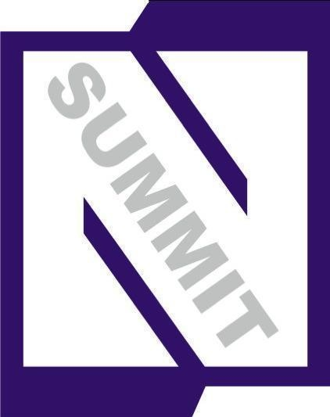

North Summit
School District
Coalville, Utah

ANNOUNCEMENT OF POSITION

The Board of Education of the North Summit School District, Coalville, Utah is seeking qualified candidates for the position of Superintendent of Schools. The position becomes vacant on July 1, 2011. Superintendent Steve Carlsen, who has successfully lead the North Summit School District for 13 years has accepted the Superintendent appointment in Carbon School District.

Applications for this position must be received by June 6, 2011. Please address applications, credentials and requests to:

Richard C. Stowell, Executive Director
Utah School Boards Association
860 East 9085 South
Sandy, Utah 84094
(801) 566-1207

All applications and credentials will be reviewed by the Board of Education. The Board will interview those candidates considered most qualified.

The North Summit School District is an equal opportunity employer.

MISSION STATEMENT

North Summit School District’s Mission Statement is: To prepare every student with the knowledge and skills needed for lifelong success in a changing world.

APPLICATION AND SELECTION PROCEDURES

To be considered for this position, an applicant’s file must be completed and received by the Utah School Boards Association (USBA) office by June 6, 2011 at 3:00 P.M., and must contain:

1. A formal letter of application stating his/her
a. Personal philosophy of education.
b. Special competencies, which qualify him/her for the superintendency.
c. Interest in this particular position.

2. A current resume in which professional preparation,
experience and a record of scholarly achievement are
clearly detailed.

3. A minimum of four current references including names,
titles, addresses, and telephone numbers.

4. Transcripts of all college and university credits. Please note: the credentials should include transcripts of all
academic work and letters of recommendation.

A letter of application, nominations, inquiries, credentials and copies of legal proof of administrative qualifications should be mailed to Richard C. Stowell at the USBA offices listed.

LEADERSHIP QUALIFICATIONS

The Board of Education of the North Summit School District is seeking an experienced administrator who:

- Has successfully implemented school reform practices with a focus on academic excellence, and is committed to the improvement of curriculum and research-based instruction.

- Has experience as a successful classroom teacher and building administrator.

- Understands and uses proven leadership and management practices.

- Follows policy and makes appropriate administrative decisions.

- Is a successful team player and comfortable with shared decision-making.

- Has excellent listening and communication skills and is accessible to the staff and public.

- Creates an atmosphere of trust and mutual respect among employees, administration, and the community.

- Is an effective advocate of school and personnel issues and needs.

- Understands rural school finance and closely monitors the development of district budgets.

- Understands and has experience with issues facing a rural school district.

- Understands and has experience working with low-income populations.

- Understands and celebrates diversity.

STUDENTS AND STAFF

There are 128 employees with a monthly payroll of $450,000.00 per month.

- Building Administrators 4
- Certified Teachers/Staff 57
- Classified/Support Staff 67

SCHOOLS AND ENROLLMENT

North Summit School District Schools:

1025 Total Enrollment

- North Summit Elementary Pre-K-4 427
- North Summit Middle 5-8 298
- North Summit High 9-12 300

BOARD OF EDUCATION

Mark Marsh, President
Arlin Ovard, Vice President
Heather Staley
Vern Williams
Mike Calderwood

The Board of Education is committed to the process of community engagement in our effort to provide the best possible education for our children. Toward this end, the Board has initiated a series of community gatherings, called “What Counts” meetings, designed to collect information on the strengths and weaknesses of our schools, and receive input on how to improve. The Board feels strongly that this process is one that truly “counts” and that community input is valued and worthwhile.

FINANCIAL

Audit Statement, June 30, 2010:

Expenditures FY10

- General Fund 7,483,936
- Capital Projects 989,250
- Debt Service 842,427
- Non K-12 602,981
- Nutrition Services 455,570
- Student Activities 407,826
- Instructional Cost 5,311,387
- Inst. Cost per Student 5,182
- Assessed Valuation 903,136,368
- Local Tax Rate .006290

ABOUT NORTH SUMMIT AND
NORTH SUMMIT SCHOOL DISTRICT…

Coalville is located for outdoor recreation. North Summit is a short drive from Salt Lake City, Ogden, Park City, Provo, and Evanston, Wyoming. In these mountain valleys you can enjoy proximity to well-developed resorts and undeveloped canyons. Wildlife can be observed in its natural habitat.

The North Summit area offers state parks, recreation, restaurants, and motels. The North Summit School District facilities offer a swimming pool, weight room, and outdoor and indoor track, which are available to the public. Each community has civic buildings and facilities that residents may also use.

POPULATION/ELEVATION

The population of Coalville is 1492, and at an average elevation of 5586 feet.

