Meeting Agenda
Welcome – 6:00 p.m.
1. Dinner hosted by USBA
2. Conversation on current Public
Education Topics

3. USBA Belief Statements

4. USBA Information

5. District Highlights

6. USBA Officer Election
Process

Adjourn – 8:00 pm
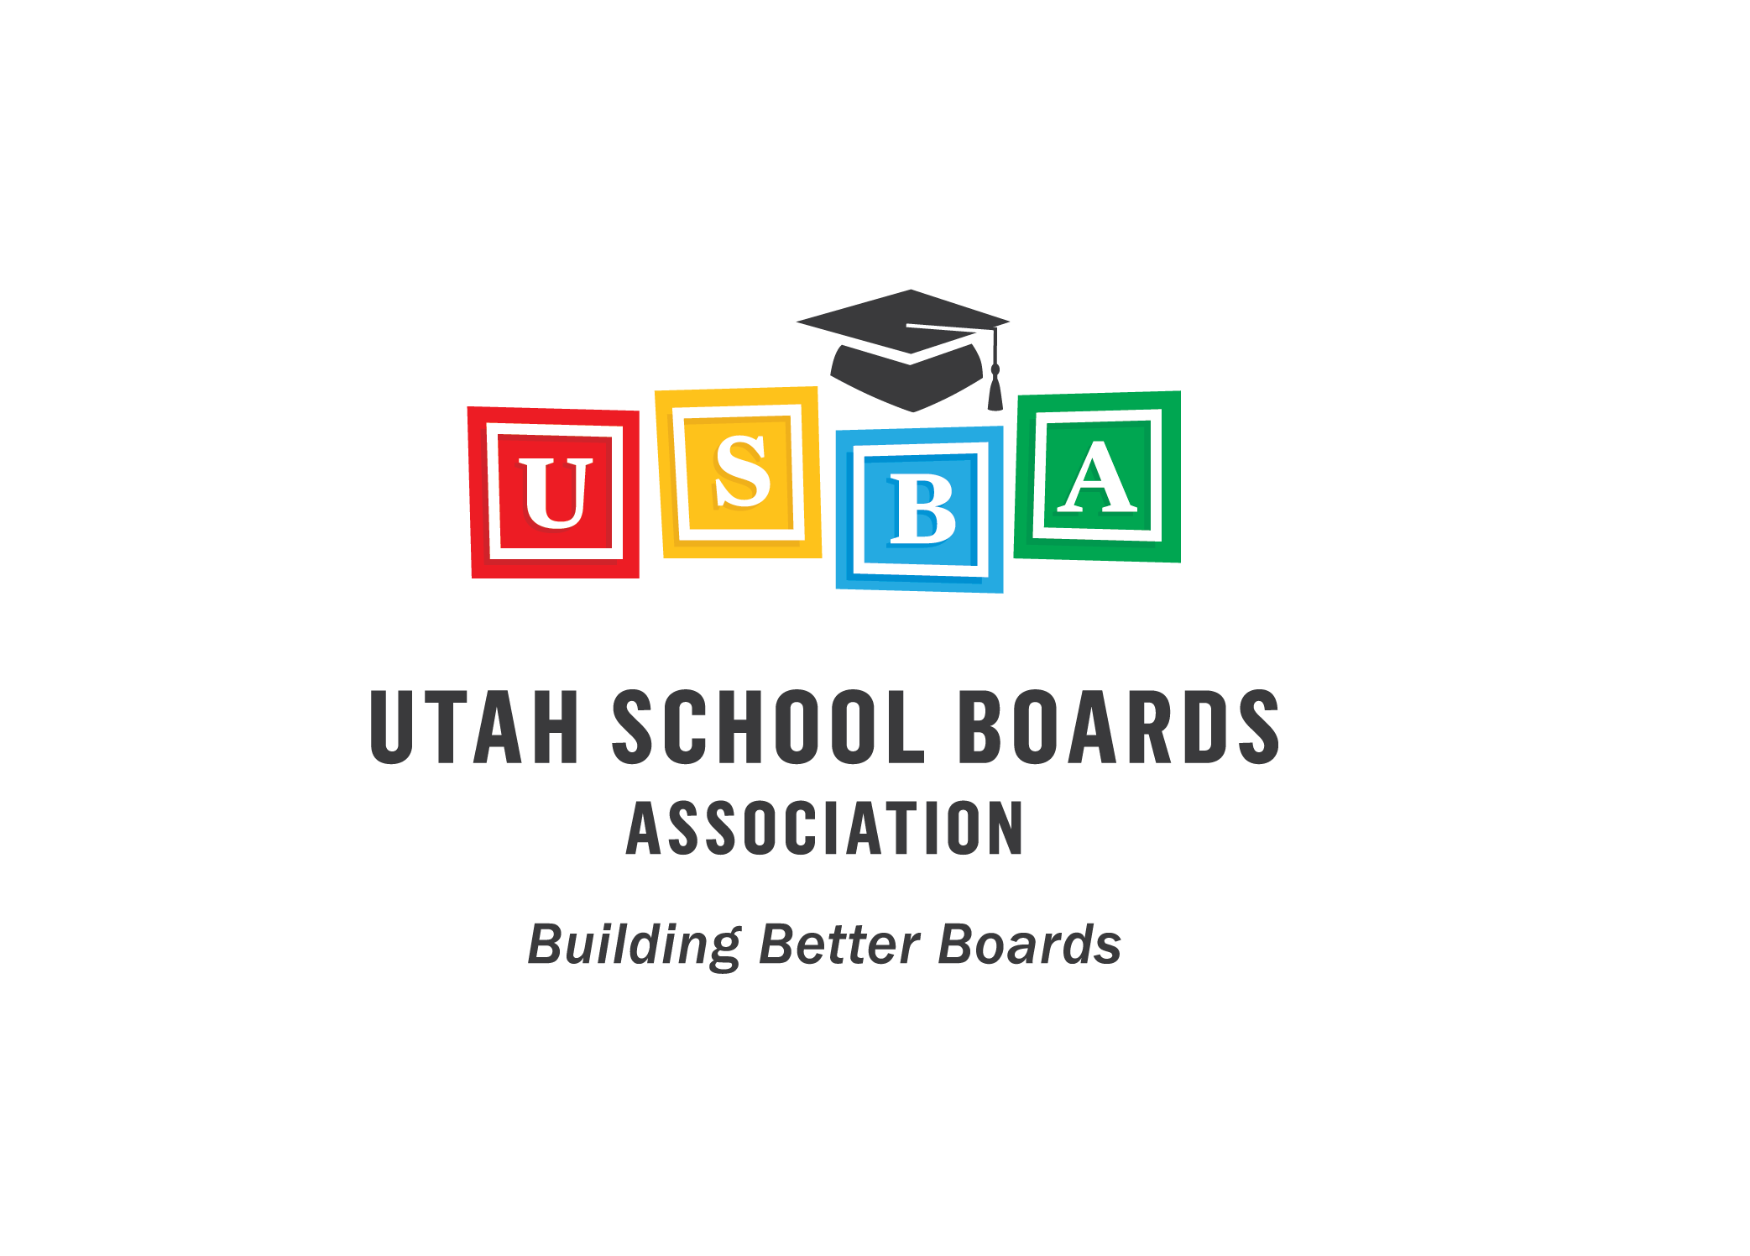

This meeting is designed for all
School Board Members
Superintendents and Business Administrators.

--2018 USBA Annual Conference--
January 4, 5, 6th
Little America Hotel

Utah School Boards Association
860 East 9085 South
Sandy, Utah 84094
Phone: (801) 566-1207
Fax: (801) 561-4579
www.usba.

2017
Fall Regional Meetings


Sponsored by:
Utah School Boards Association

