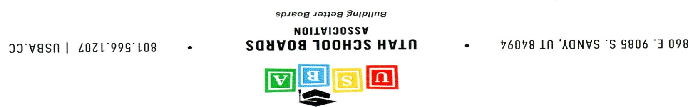

**Pre-Delegate Assembly**

**June 6, 2025**

Canyons Administration Building East

9361 South 300 East

Sandy, UT 84070

6:00 Welcome

6:05 Dinner

6:45 Legislative Panel

7:45 Priority FAQ

8:00 Dismiss